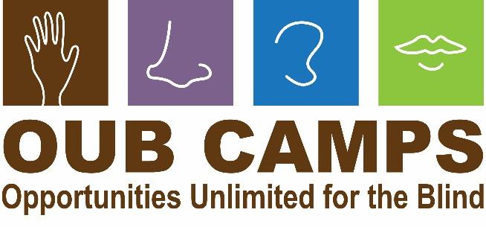

Opportunities Unlimited for the Blind’s mission: building life skills, self-confidence and independence for children and young adults who are blind or have low vision.

**Schedule for 2025 Camps!**

Ice Fishing with Maureen – Family or Camper Event, February 15-16, Leaving Grand Rapids at 8 Am Saturday, returning Sunday evening. Lot of fun! Ask Gwen for a registration form soon! See below.

April Fool’s Day Event – OUB Zoom Event – Saturday, March 29, 11 Am – 12:30 PM

Camp Clean-up Day – volunteers welcome! Saturday, April 26, 9 AM – 3 PM, lunch provided – event is FREE

Garden Day – at camp! Saturday, May 3, 10 AM – 3 PM, lunch provided, event is free!

Additional Cleaning Days – TBA

Staff Training – June 6 – 15

Cooking and Serving Camp – ages 10-17, June 15-20 Learn to cook exciting new foods and do a service project to help our community!

Discovery Camp – ages 7- 17, June 22-27 Science Camp! All kinds of great activities from Architecture to Zoology! Also available as a day camp.

Family Day! – all ages, June 27. Fun for Everyone! Lunch provided – cooked by campers! Event is free!

Bicycle Camp – ages 7-17, June 30 – July 3 (4 days) Arrive Monday morning and leave Thursday afternoon – 4 days of great biking experiences and self-defense classes! Also available as a day camp.

Cooking and Jamming Camp – ages 7-17, July 6-11 Cooking, music and more! Exciting times in the world of food and art, or food as art! And Music, lots of music!

Adventure Trip – ages 12-17, July 15 – July 24 Back to the UP! We will be kayaking to an island in Lake Superior and camping there for several days while kayaking and exploring the area around Grand Island and Pictured Rocks National Lakeshore. Alternative activities available for those not quite ready for the entire paddling experience, including waterfall hunting and hiking in the beautiful Pictured Rocks area. Accepting adventurous 11 year-olds!

Gwen Botting, Executive Director

Opportunities Unlimited for the Blind

4175 Westbrook Road

Ionia, MI 48846

616-755-2221 (Cell)

[www.oubmichigan.org](http://www.oubmichigan.org)

[gwen@oubmichigan.org](mailto:gwen@oubmichigan.org)